DOCUMENTATION

ASSIGNMENT 1

STUDENT NAME: CORNOC DARIUS ANDREI
GROUP: 30423

CONTENTS

1. Assignment Objective 3
2. Problem Analysis, Modeling, Scenarios, Use Cases 3
3. Design 6
4. Implementation 9
5. Results 11
6. Conclusions 12
7. Bibliography 13

Assignment Objective
The assignment’s objective is to design and implement a polynomial calculator with a dedicated graphical interface through which the user can insert polynomials, select the mathematical operation (addition, subtraction, multiplication, division, derivative, integration) to be performed and view the result.

The sub-objectives needed for attaining this aim are:
- Analyze the problem and identify requirements
- Design the polynomial calculator
- Implement the polynomial calculator
- Test the polynomial calculator

Problem Analysis, Modeling, Scenarios, Use Cases
The functional requirements for the polynomial calculator are the following:
- The calculator should allow users to input polynomial in a standard format.
- The calculator should support basic arithmetic operations on polynomials, including addition, subtraction, multiplication, division, derivation and integration.
- The calculator should allow users to select the mathematical operation they want to perform.
- The calculator should provide clear error messages for invalid inputs or operations.
The non-functional requirements of the project are:
- The calculator should provide quick responses to user inputs.
- The user interface should be intuitive and easy to use.
- The calculator should utilize memory efficiently.

The use case diagram presented below illustrates the various interactions between the users and the system of the polynomial calculator application.
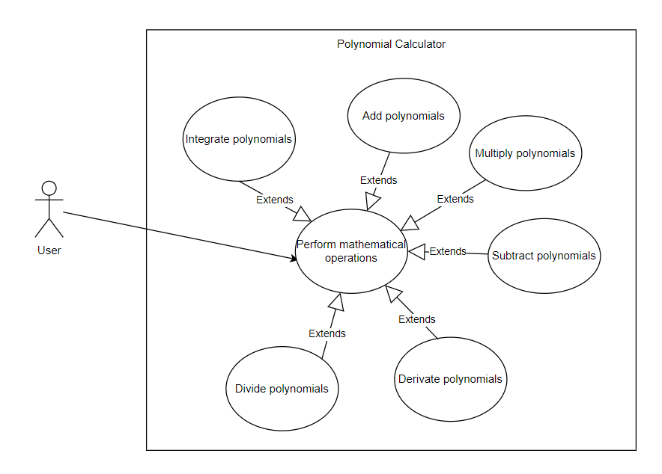 Figure 1. Use case diagram

The use case descriptions will be provided in the next part:

- Use Case: Add polynomials
Primary Actor: User
Main Success Scenario:
- The user inserts the 2 polynomials in the graphical user interface
- The user clicks on the “+” button
- The polynomial calculator performs the addition of the two polynomials and displays the result
Alternative Sequence:
- The user inserts incorrect polynomials
- The calculator shows an error message
- The scenario returns to step 1

- Use Case: Subtract polynomials
Primary Actor: User
Main Success Scenario:
- The user inserts the 2 polynomials in the graphical user interface
- The user clicks on the “-” button
- The polynomial calculator performs the subtraction of the two polynomials and displays the result
Alternative Sequence:
- The user inserts incorrect polynomials
- The calculator shows an error message
- The scenario returns to step 1

- Use Case: Multiply polynomials
Primary Actor: User
Main Success Scenario:
- The user inserts the 2 polynomials in the graphical user interface
- The user clicks on the “x” button
- The polynomial calculator performs the multiplication of the two polynomials and displays the result
Alternative Sequence:
- The user inserts incorrect polynomials
- The calculator shows an error message
- The scenario returns to step 1

- Use Case: Divide polynomials
Primary Actor: User
Main Success Scenario:
- The user inserts the 2 polynomials in the graphical user interface
- The user clicks on the “/” button
- The polynomial calculator performs the division of the two polynomials and displays the quotient and the remainder
Alternative Sequence:
- The user inserts incorrect polynomials or inputs a denominator of 0
- The calculator shows an error message
- The scenario returns to step 1

- Use Case: Derivate polynomials
Primary Actor: User
Main Success Scenario:
- The user inserts the P polynomial in the graphical user interface
- The user clicks on the “dP/dx” button
- The polynomial calculator performs the derivation of the polynomial introduced and displays the result
Alternative Sequence:
- The user inserts an incorrect polynomial
- The calculator shows an error message
- The scenario returns to step 1

- Use Case: Integrate polynomials
Primary Actor: User
Main Success Scenario:
- The user inserts the P polynomial in the graphical user interface
- The user clicks on the “∫” button
- The polynomial calculator performs the integration of the polynomial introduced and displays the result
Alternative Sequence:
- The user inserts an incorrect polynomial
- The calculator shows an error message
- The scenario returns to step 1

Design
The design is divided on more levels. At the first level the inputs and the outputs of the system must be determined. The inputs for the polynomial calculator are the 2 polynomials inserted by the user and the operation to be performed. The output is represented by the result of the operation.

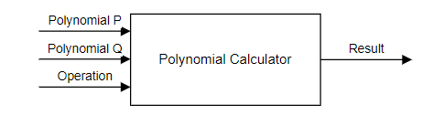
Figure 2. The overall system design

The second level involves dividing the system into packages. The graphical user interface contains the classes that will deal with the interface presented to the user. The business logic package contains the classes that perform the mathematical operations on the polynomials. The data models package contains the classes modeling the application.

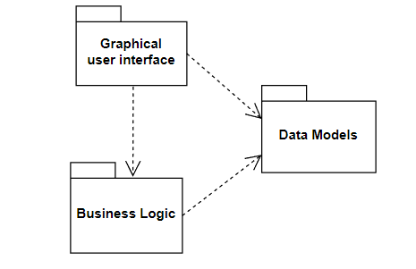
Figure 3. UML package diagram

At the third level, the classes contained in each package should be determined. The Graphical user interface should contain the Application class, which is responsible for launching the application, and the SceneController class, which is a controller that contains the logic for the action that must be performed when the buttons are clicked. The Business logic package should contain the class responsible for computing the result of the arithmetic operations on the polynomials, namely OperationsPolynomial class. The Data models package should contain the Polynomial and the Fraction classes.

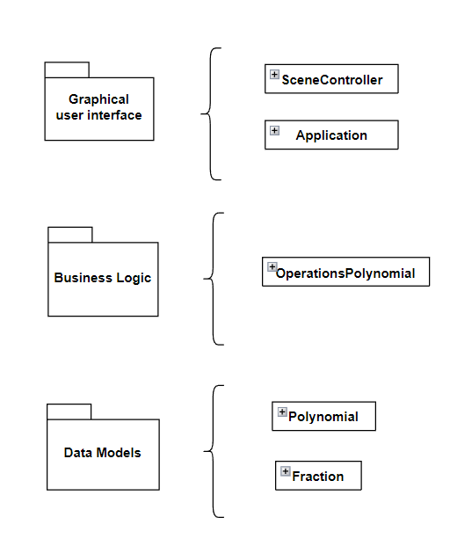
Figure 4. Division into classes

The fourth level is represented by the class diagram design. Designing a class diagram involves structuring and organizing the classes and establishing the relationships between them. In the context of the polynomial calculator application, designing a class diagram would involve identifying the key attributes and methods associated to each class involved in representing polynomials, fractions and their operations.

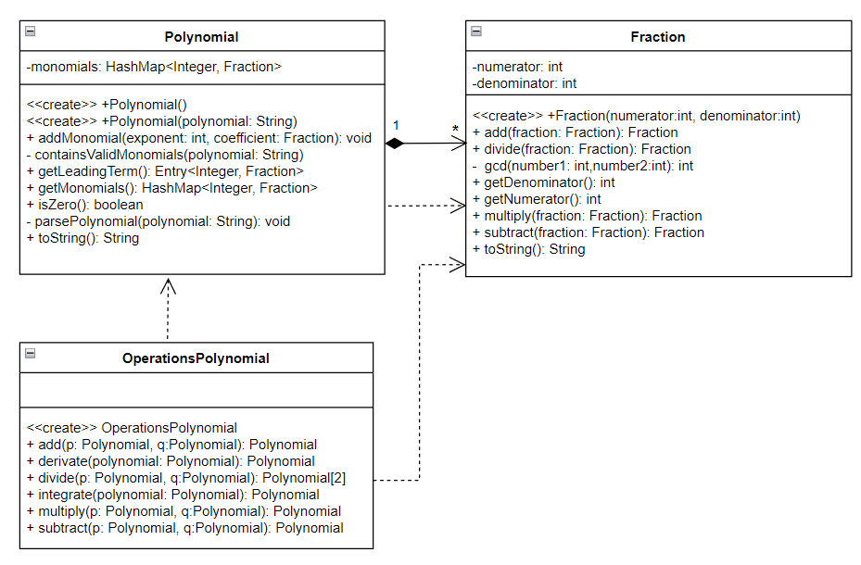
Figure 5. UML class diagram

Implementation
The Polynomial class contains a list of monomials that implement a polynomial. The monomials were stored in a data structure called hash map which has O(1) complexity time for searching an element. The decision of using a hash map was based on comparing the performance of different collections from the Java Collection^{[2]}. The important methods implemented in this class are:
- containsValidMonomials(polynomial:String) method which is used for checking if a string is a valid polynomial in one variable. For checking this, regex expressions were used^{[3]}.
- parsePolynomial(polynomial:String) method used for adding the monomials from a string to the monomials field of the class
- isZero() method which is used to check if the polynomial is 0
- getLeadingTerm() method which returns the lead term of the polynomial
The Fraction class contains 2 fields of type int: the numerator and the denominator. The methods implemented in this class deal with the arithmetic operations on fractions, such as addition or subtraction. Another method used is gcd(number1:int, number2:int) which computes the greatest common divisor such that the fractions will be irreducible after the execution of the arithmetic operations.
The OperationsPolynomial class has methods that are used for performing arithmetic operations on polynomials.
The add(p: Polynomial, q:Polynomial) method, aims to add two polynomial objects, p and q, together and return the result. The addition process is implemented by iterating through the monomials of both polynomials, adding corresponding terms with the same exponents, ensuring that non-zero coefficients are included in the resulting polynomial.
The subtract(p: Polynomial, q:Polynomial) method is designed to subtract one polynomial (q) from another polynomial (p). This is achieved by negating the coefficients of all monomials in the second polynomial and then invoking the addition method.
The multiply(p: Polynomial, q:Polynomial) method is responsible for multiplying two polynomials. It employs nested iterations over the monomials of both polynomials, calculating the product of each pair of monomials and accumulating the results in an intermediary polynomial. The final result is obtained by iteratively adding these intermediary polynomials.
The derivate(polynomial: Polynomial) method facilitates the differentiation of a given polynomial. It iterates through the monomials of the polynomial, computing the derivative of each term, and constructs a new polynomial representing the derivative.
The integrate(polynomial: Polynomial) method is designed to perform the integration of a polynomial. It iterates through the monomials of the polynomial, computing the indefinite integral of each term, and aggregates the results to construct the integral polynomial.
The divide(p: Polynomial, q:Polynomial) is responsible for computing the division of 2 polynomials. The pseudocode for the algorithm used for division is presented in the figure 4. It takes 2 polynomials, returning a pair of polynomials representing the quotient and the remainder. It requires that the denominator polynomial is different than 0. Firstly, the quotient is initialized to 0 and the remainder to the numerator polynomial. As long as the remainder is different than 0 and the degree of the remainder remains greater than the degree of the denominator polynomial, the leading terms of the remainder and denominator polynomial are divided. The result is added to the quotient and the remainder gets updated by subtracting the product of the division of leading terms and the denominator polynomial from the current remainder.

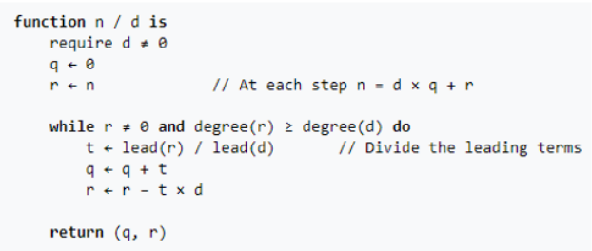
Figure 6. Polynomial division algorithm

The graphical user interface was implemented using JavaFX. It consists of a window that has text fields where the user can insert polynomials, buttons for selecting the operation to be performed, a text area where the result is displayed and labels where the error messages are displayed. Each button has associated a method that on click, they generate the creation of polynomials objects from the introduced polynomials and trigger the execution of the corresponding operation, inserting the result into the text area.

Results
The testing scenarios have been used for checking if the arithmetic operations with polynomials and fractions are correct. In order to check if the operations with polynomials give the correct result, two polynomials were chosen and the required mathematical operations were performed on them, as it is depicted in figure 7. For checking if the operations on fractions are correct, two fractions were chosen and the mathematical operations were performed on them, as it can be seen in figure 8. Each test case passed successfully, ensuring the correctness of polynomial and fraction operations. The outcomes of the tests that were carried out can be seen in the figure 9.
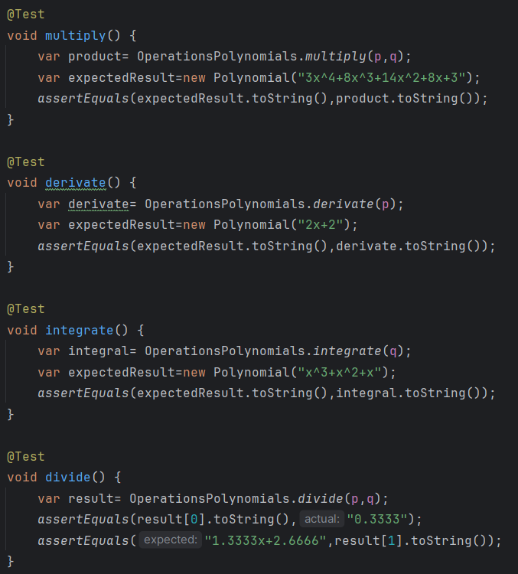
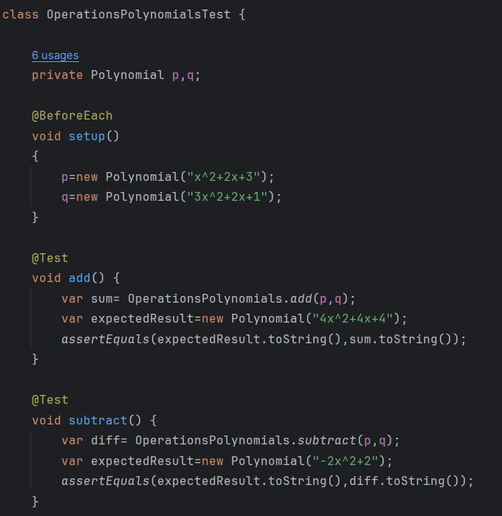
Figure 7. Tests for arithmetic operations on polynomials

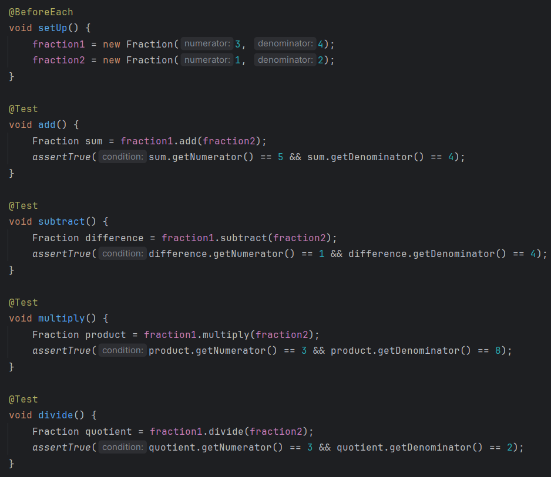
Figure 8. Tests for arithmetic operations on fractions

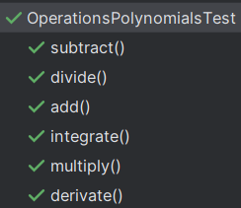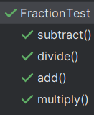
(a) (b)
Figure 9. (a) Tests outcomes for operations on polynomials.
(b) Tests outcomes for operations on fractions

Conclusions
In conclusion, through careful design and implementation, I have created a functional and user-friendly Graphical User Interface (GUI) that allows users to perform various polynomial operations with ease. The assignment gave me the opportunity to gain a deeper understanding of implementing an application with an intuitive graphical user interface based on the specifications of a problem.
Some future developments would include expanding the functionality of the application by adding a feature that computes the roots of the polynomial, drawing the graph of the polynomial and computing the value of the polynomial in specific points selected by the user.

Bibliography
- https://dsrl.eu/courses/pt/materials/PT_2024_A1_S1.pdf
- https://www.baeldung.com/java-collections-complexity
- https://docs.oracle.com/javase/7/docs/api/java/util/regex/Pattern.html

